**Knapsack 0/1 Output:**

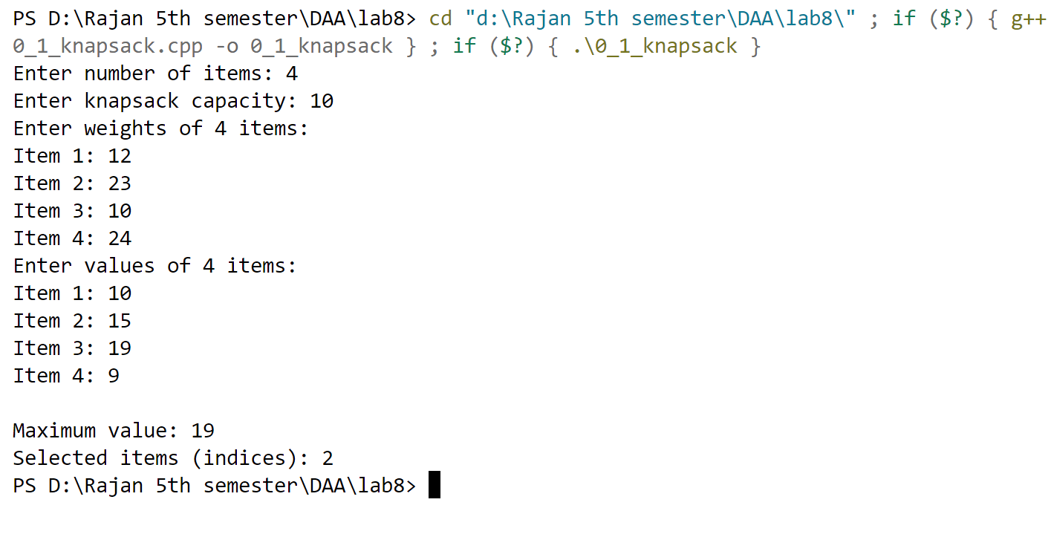

**Subset Sum problem Output:**

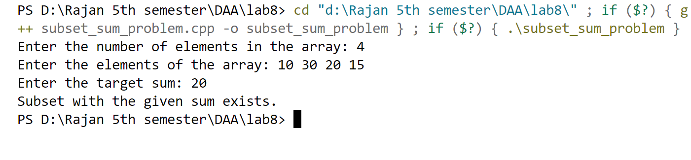

**String Editing Output:**

